DRUG SAFETY NOTICE
SUPPLY CHANGE
DRUG NAME/STRENGTH/FORM:
THIAMINE HYDROCHLORIDE 200mg in 2ml IV
(TO REPLACE PABRINEX IV SHORTAGE)
PROBLEM
- Pabrinex supplies will not be available indefinitely once current reserves run out.
- There are no other licensed parenteral alternatives to Pabrinex intravenous and intramuscular injections.
- Thiamine hydrochloride IV (Thiamine IV) is an unlicensed alternative to Pabrinex for the two indications outlined below (alcohol dependency and preventing refeeding syndrome).

ADVICE
Trust Guidelines are currently being updated to reflect the following:
- Clinicians should NOT initiate new patients on Pabrinex IV
- Thiamine IV will be used in place of Pabrinex. Please see specific indications below for further advice and dosing.
- Each 2ml vial contains 200mg of thiamine HCL (100mg per 1ml)
- Each original pack contains 25 x 2 ml vials
- Sample image of an original pack:
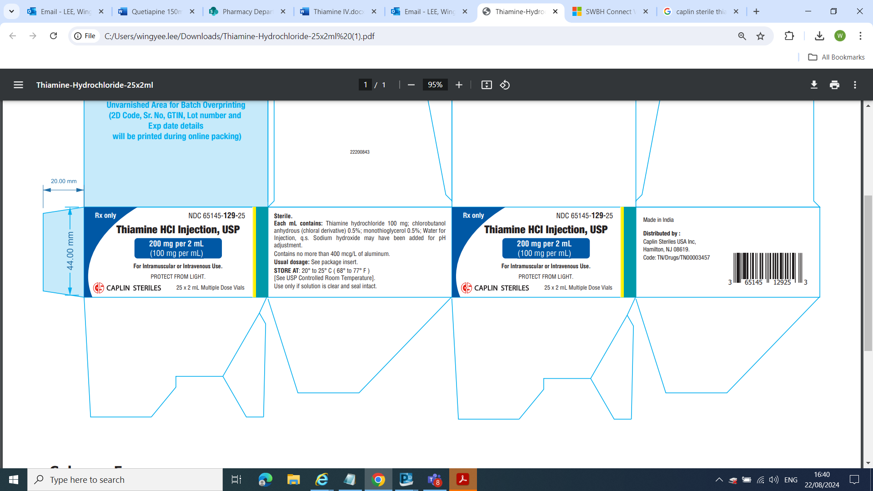

THIAMINE IV DOSING
Indication | Dose | Frequency | Duration
Prophylaxis of Wernicke’s encephalopathy | 200mg to 300mg IV | OD | 3 to 5 days with daily review and monitoring for emergent signs of Wernicke’s encephalopathy.
Treatment of Wernicke’s encephalopathy | 300mg to 500mg IV | TDS | 3 to 5 days with daily review.  If still symptomatic after 5 days of treatment, then give:  300mg to 500mg OD for a further 3 to 5 days for as long as clinical improvement continues.
Prophylaxis of Refeeding Syndrome | 200mg to 300mg IV | OD prior to starting parenteral nutrition | Continue for at least 2 more days (total course of 3 days).  In higher-risk patients:  Continue for 4 more days (total course of 5 days).

FURTHER CLINICAL INFORMATION

THIAMINE IN ALCOHOL DEPENDENCE
Intravenous thiamine is an unlicensed alternative that can be used in people at high risk of Wernicke’s encephalopathy.

Prophylaxis for people at risk

Defining people at risk
NICE CG100 recommends offering prophylactic parenteral thiamine followed by oral thiamine to harmful or dependent drinkers if they:
- are malnourished or at risk of malnourishment or
- have decompensated liver disease

and in addition:
- they attend an emergency department or
- are admitted to hospital with an acute injury or illness

People at high risk of Wernicke’s encephalopathy can have a range of conditions, including:
- significant weight loss
- poor diet
- low BMI (<18)
- other signs of malnutrition
- memory disturbance
- peripheral neuropathy
- previous history of Wernicke’s encephalopathy

Consider offering prophylactic parenteral thiamine to people at high risk following the dosing below.

DOSING
Give intravenous thiamine 200 to 300mg once daily for 3 to 5 days with daily review and monitoring for emergent signs of Wernicke’s encephalopathy.

Treating Wernicke’s encephalopathy

Identifying symptoms
People with any of the additional symptoms below require treatment for Wernicke’s encephalopathy.
- impaired eye movements (ophthalmoplegia)
- unsteady walking (ataxia)
- Confusion.

DOSING
- Give intravenous thiamine 300 to 500mg three times a day for 3 to 5 days with daily review
- If the individual is still symptomatic after 5 days of treatment, then give intravenous thiamine 300mg to 500mg once daily for a further 3 to 5 days for as long as clinical improvement continues
- Other causes for their confusion should be explored.

THIAMINE TO PREVENT REFEEDING SYNDROME

Thiamine for refeeding syndrome
During refeeding syndrome, the demand for thiamine increases which can lead to a depletion of stores.
Thiamine replacement is thus indicated to prevent complications from thiamine deficiency such as the development of Wernicke’s encephalopathy which can progress to Korsakoff’s syndrome.

Products and availability

Intravenous thiamine
Intravenous thiamine is an alternative to Pabrinex that can be used in some patients where indicated, although no product with a marketing authorisation currently exists in the UK.

Use oral thiamine and vitamin B first
Oral thiamine and vitamin B compound strong should be used first where supplementation is clinically indicated and appropriate.

Use intravenous thiamine if high risk
If the oral or enteral route is not available, prescribe intravenous thiamine at the lowest clinically suitable dose and course length for patients at high or extremely high risk of refeeding syndrome. Determine risk based on NICE CG32 as follows:

High risk
Patient has 1 or more of the following:
- BMI less than 16kg/m2
- Unintentional weight loss greater than 15% within the last 3 to 6 months
- little or no nutritional intake for more than 10 days
- low levels of potassium, phosphate or magnesium before feeding

Or patient has 2 or more of the following:
- BMI less than 18.5kg/m2
- Unintentional weight loss greater than 10% within the last 3 to 6 months
- Little or no nutritional intake for more than 5 days
- A history of alcohol abuse or drugs including insulin, chemotherapy, antacids or diuretics

Extremely high risk
Patient has the following:
- BMI less than 14 kg/m² with negligible nutrition for more than 15 days.

Doses of intravenous thiamine
Where intravenous thiamine is indicated, the following doses can be used.

Adults
- Give 200-300mg once daily prior to starting parenteral nutrition
- Continue for at least 2 more days (total course of 3 days); or 4 more days (total course of 5 days) in higher-risk patients.

Key resources
SmPC Pabrinex Intravenous High Potency, Concentrate for Solution for Infusion
BNF Vitamin B substances with ascorbic acid
NICE CG100 Alcohol-use disorders: diagnosis and management of physical complications
NICE CG32 Nutrition support for adults: oral nutrition support, enteral tube feeding and parenteral nutrition
Guidance on prescribing thiamine for patients at risk of refeeding syndrome
Using and prescribing thiamine in alcohol dependence

FOR FURTHER INFORMATION CONTACT YOUR WARD BASED PHARMACY TEAM
OR
THE PHARMACY DEPARTMENT (CITY ext.5263; SANDWELL ext.3783).

DATE OF ISSUE: 03.09.2024 | REFERENCE NUMBER: 01-0924

