**Adding diet and fluid recommendations on Unity**

1. To add a “Diet and Fluids” order on unity, go to the request/care plans tab and click “add”.
2. Type “Diet and Fluids” into the search box and select this option.

1. In the order form drop downs, select the relevant items.

Note both the ‘Beverage modifiers’ (fluids) box and the ‘Dietary Modifiers’ box are mandatory. You must select the appropriate consistency for your patient.

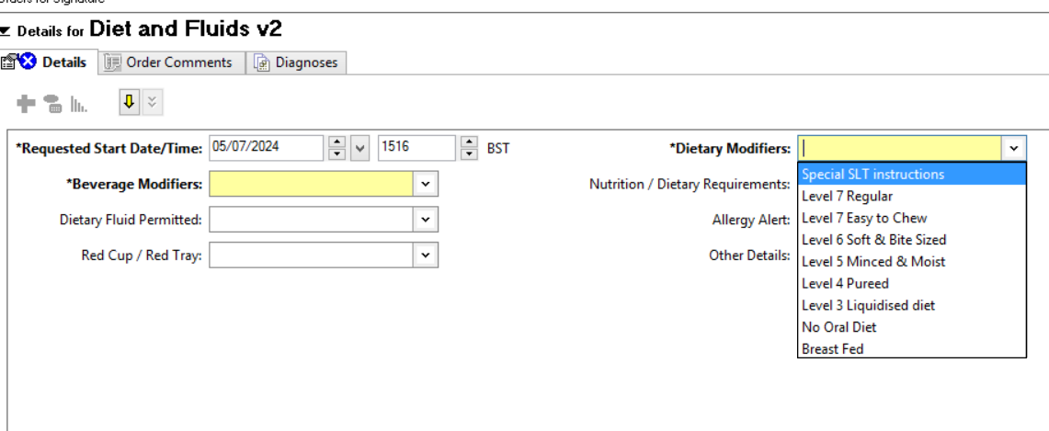

There are now separate drop downs for selecting whether your patient requires Red cup/Red tray support, specific food allergies and any dietary requirements.

**If you need to select multiple allergies or dietary requirements e.g. Gluten Free and Vegetarian or Milk and Peanut allergy, you will need to hold down the CTRL key on the keyboard whilst making your selection.**

1. Click Sign
2. Refresh and check your order has been placed.