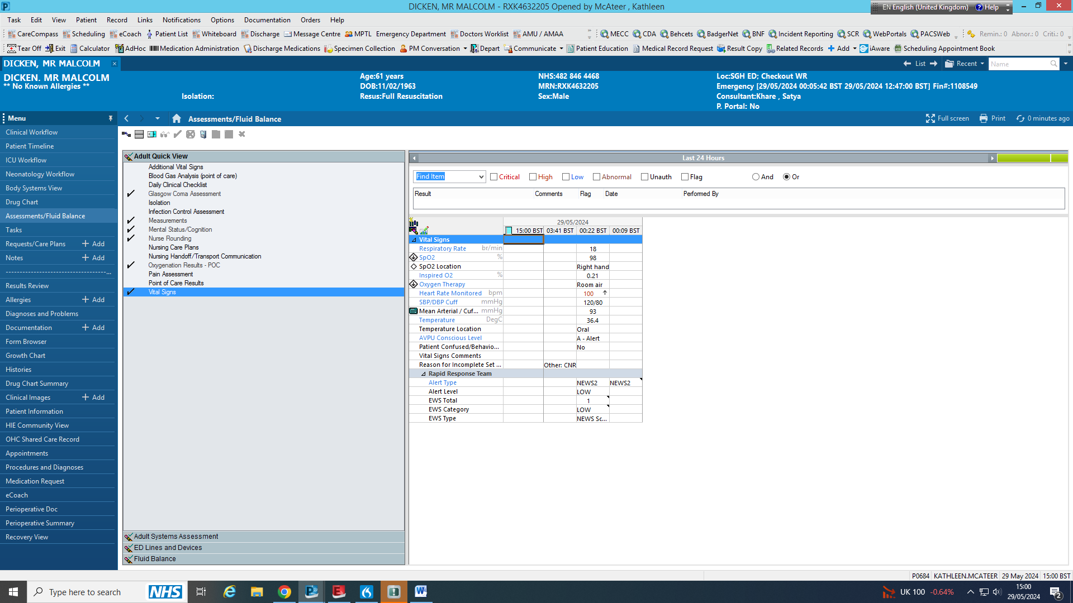

**1. Click ‘Assessments/fluid balance’.**

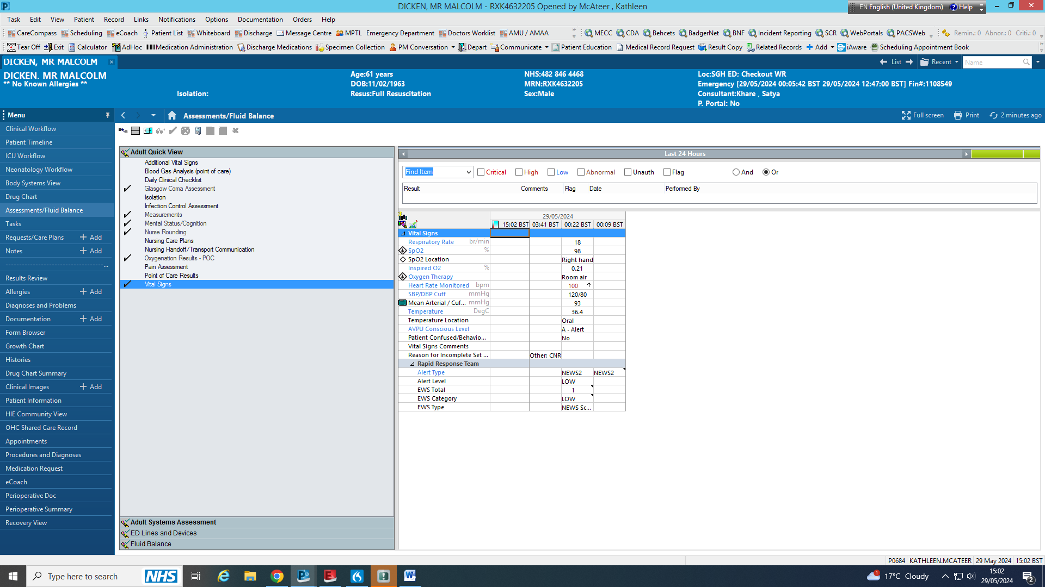

**2. Click ‘Adult Systems Assessment’.**

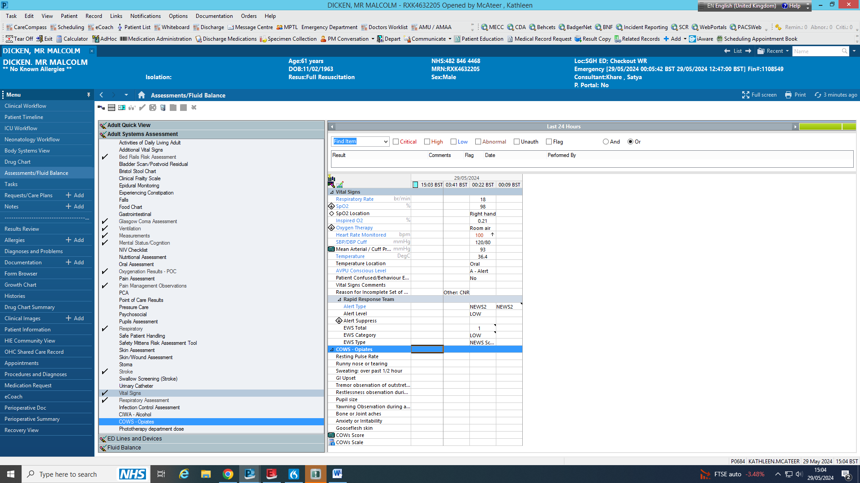

**3. Click ‘COWS - Opiates’.**

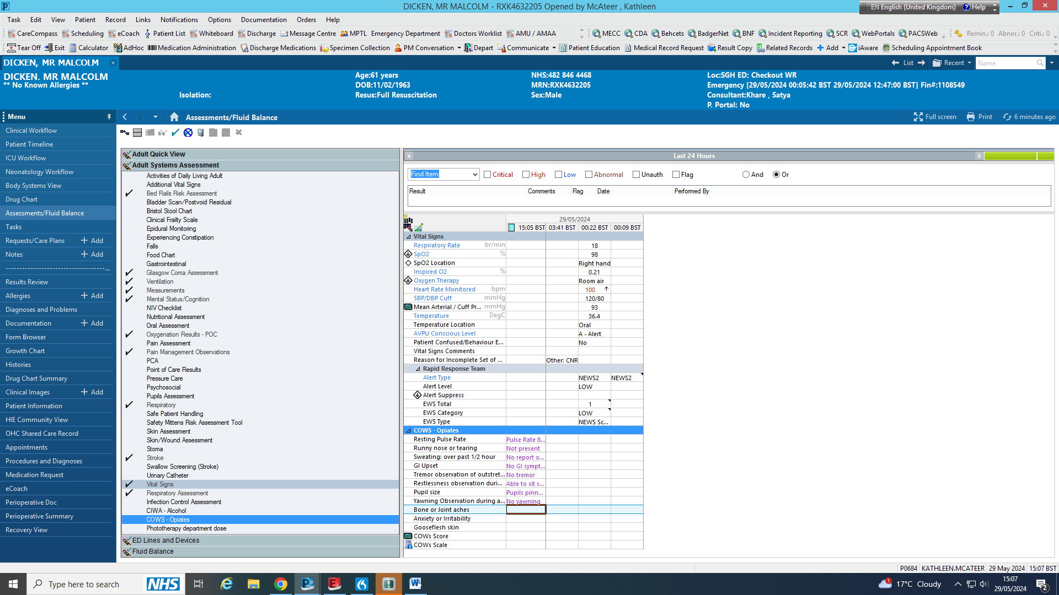

**4. Click on the boxes to bring down a drop down box. Select the appropriate response.**

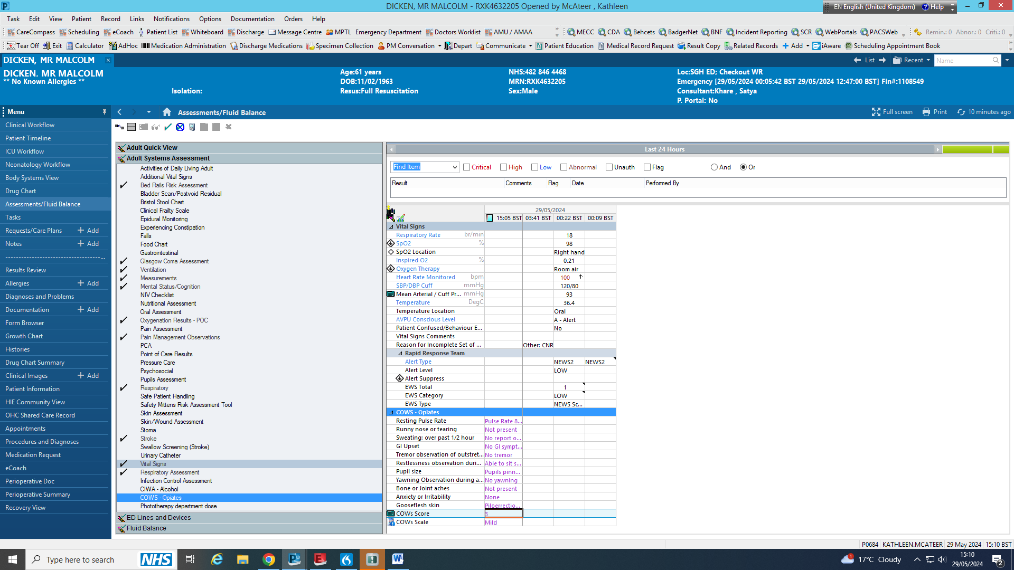

**5. Double click to calculate total.**

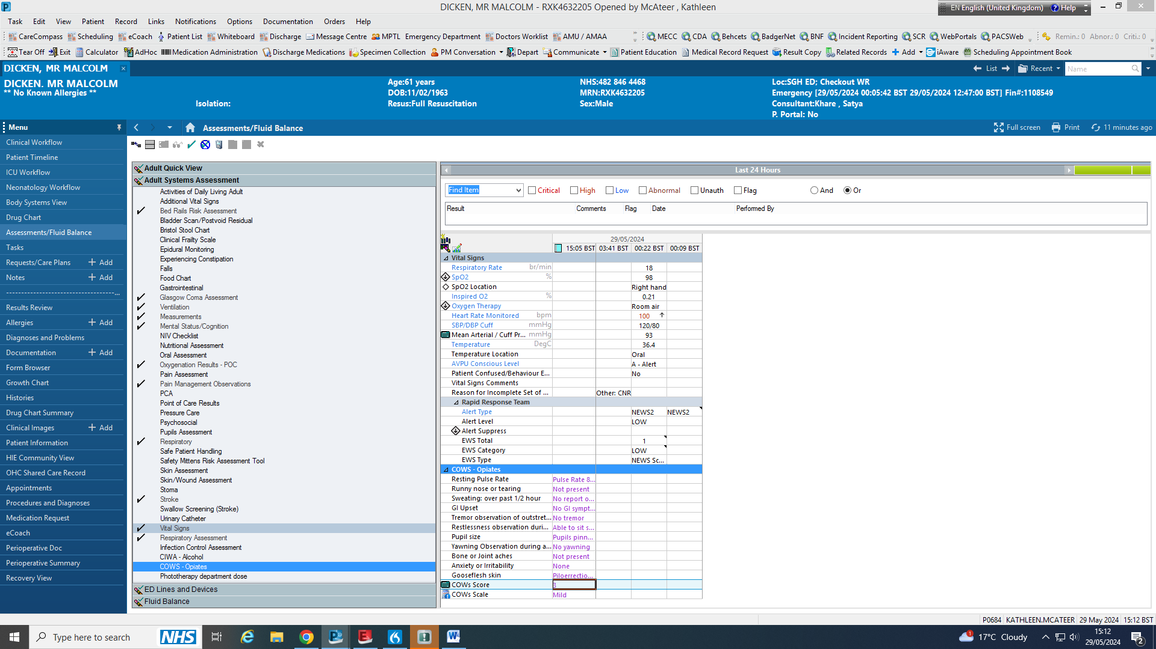

**6. Click to submit.**

**Mild withdrawals scores 5-12.  
Moderate withdrawals scores 13-24.  
Moderately Severe Withdrawal scores 25-36.  
Severe withdrawal is over 36.**

**Please ensure you are escalating to medical teams if a patient scores over 13 on COWS.**

**COWS will appear here.**

**How to access clinical opiate withdrawal scale (COWS) on unity**