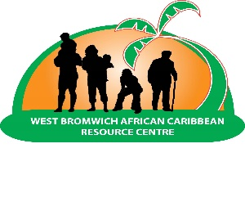

Health & Well Being Divisions Team Leader

Job Summary:
The Health & Well Being Division Team Leader will play a pivotal role in overseeing and managing services within the Health & Well Being Division at West Bromwich African Caribbean Resource Centre (WBACRC). The incumbent will be responsible for leading a team to deliver a range of services focused on dementia support, day opportunities, gentle exercise, carers and SAPPHIRE services. The primary goal is to enhance the well-being of service users, particularly those from African Caribbean communities, by providing culturally sensitive and effective support.

Qualifications:
Health and Social Care Level 3 Health qualification and willingness to work towards achieving level 4 or a similar qualification and/or equivalent experience, commensurate with the responsibilities of this role.

Opening Date: Monday 18th March 2024
Closing date: Friday 5th April 2024
Recruitment Lead Partner: West Bromwich African Caribbean Resource Centre
Salary: £ 15.00 per hour (£21,840.00)
Hours: 28 hours per week based over 4 days (Monday – Friday)
Flexible days on Thursdays and Fridays
Office Location: West Bromwich
Contract type: Fixed Term 12-month contract, review after this period. (6 Month Probation), review
Interview date: To be Confirmed

To apply for the role, please contact info@wbacrc.org.uk or phone Naffisa Williams on 0121 525 9177(choose option 5), initially individuals will be asked to email their CV to our info account, if people meet the access criteria they will be sent a job application pack.

