**Sweet Little Easter Baskets**

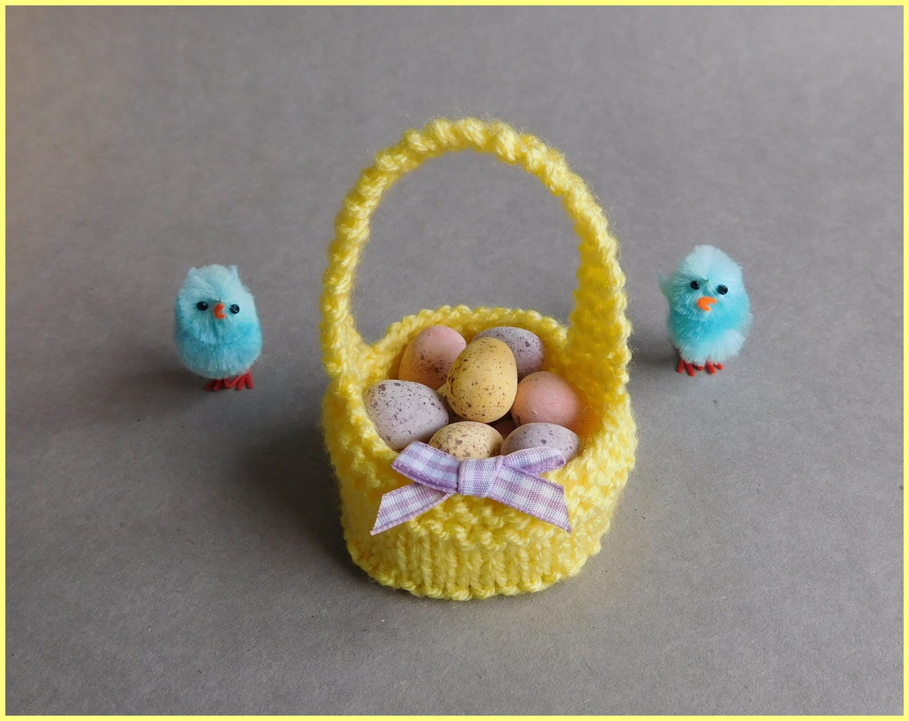

**Basket Pattern**

Cast on 41sts

Knit 4 rows

Stocking stitch 4 rows

Knit 2 rows

**Shape Bottom of the basket**

1st Row:        *K8, k2tog, repeat from * to last st, k1                       (37sts)

2nd Row:        S1, *p7, p2tog tbl, repeat from * to end of row            (33sts)

3rd Row:        *K6, k2tog, repeat from * to last st, k1                       (29sts)

4th Row:        S1, *p5, p2tog tbl, repeat from * to end of row             (25sts)

5th Row:        *K4, k2tog, repeat from * to last st, k1                       (21sts)

6th Row:        S1, *p3, p2tog tbl, repeat from * to end of row             (17sts)

7th Row:       *K2tog, repeat from * to last st, k1                                       (9sts)

Cut yarn (leaving a short ‘tail’ to use for sewing up), draw the end through all stitches, pull up tightly.

Sew up the seam.  Darn away ends.

**Handle:**

Cast on 4sts

Knit 45 rows

Cast off

Join onto the opposite side of the basket

Darn away ends

Decorate if desired

Optional:  Cut out a circle of thin card to line the base (around 2¼“ in diameter)

Fill the basket with chocolate mini eggs