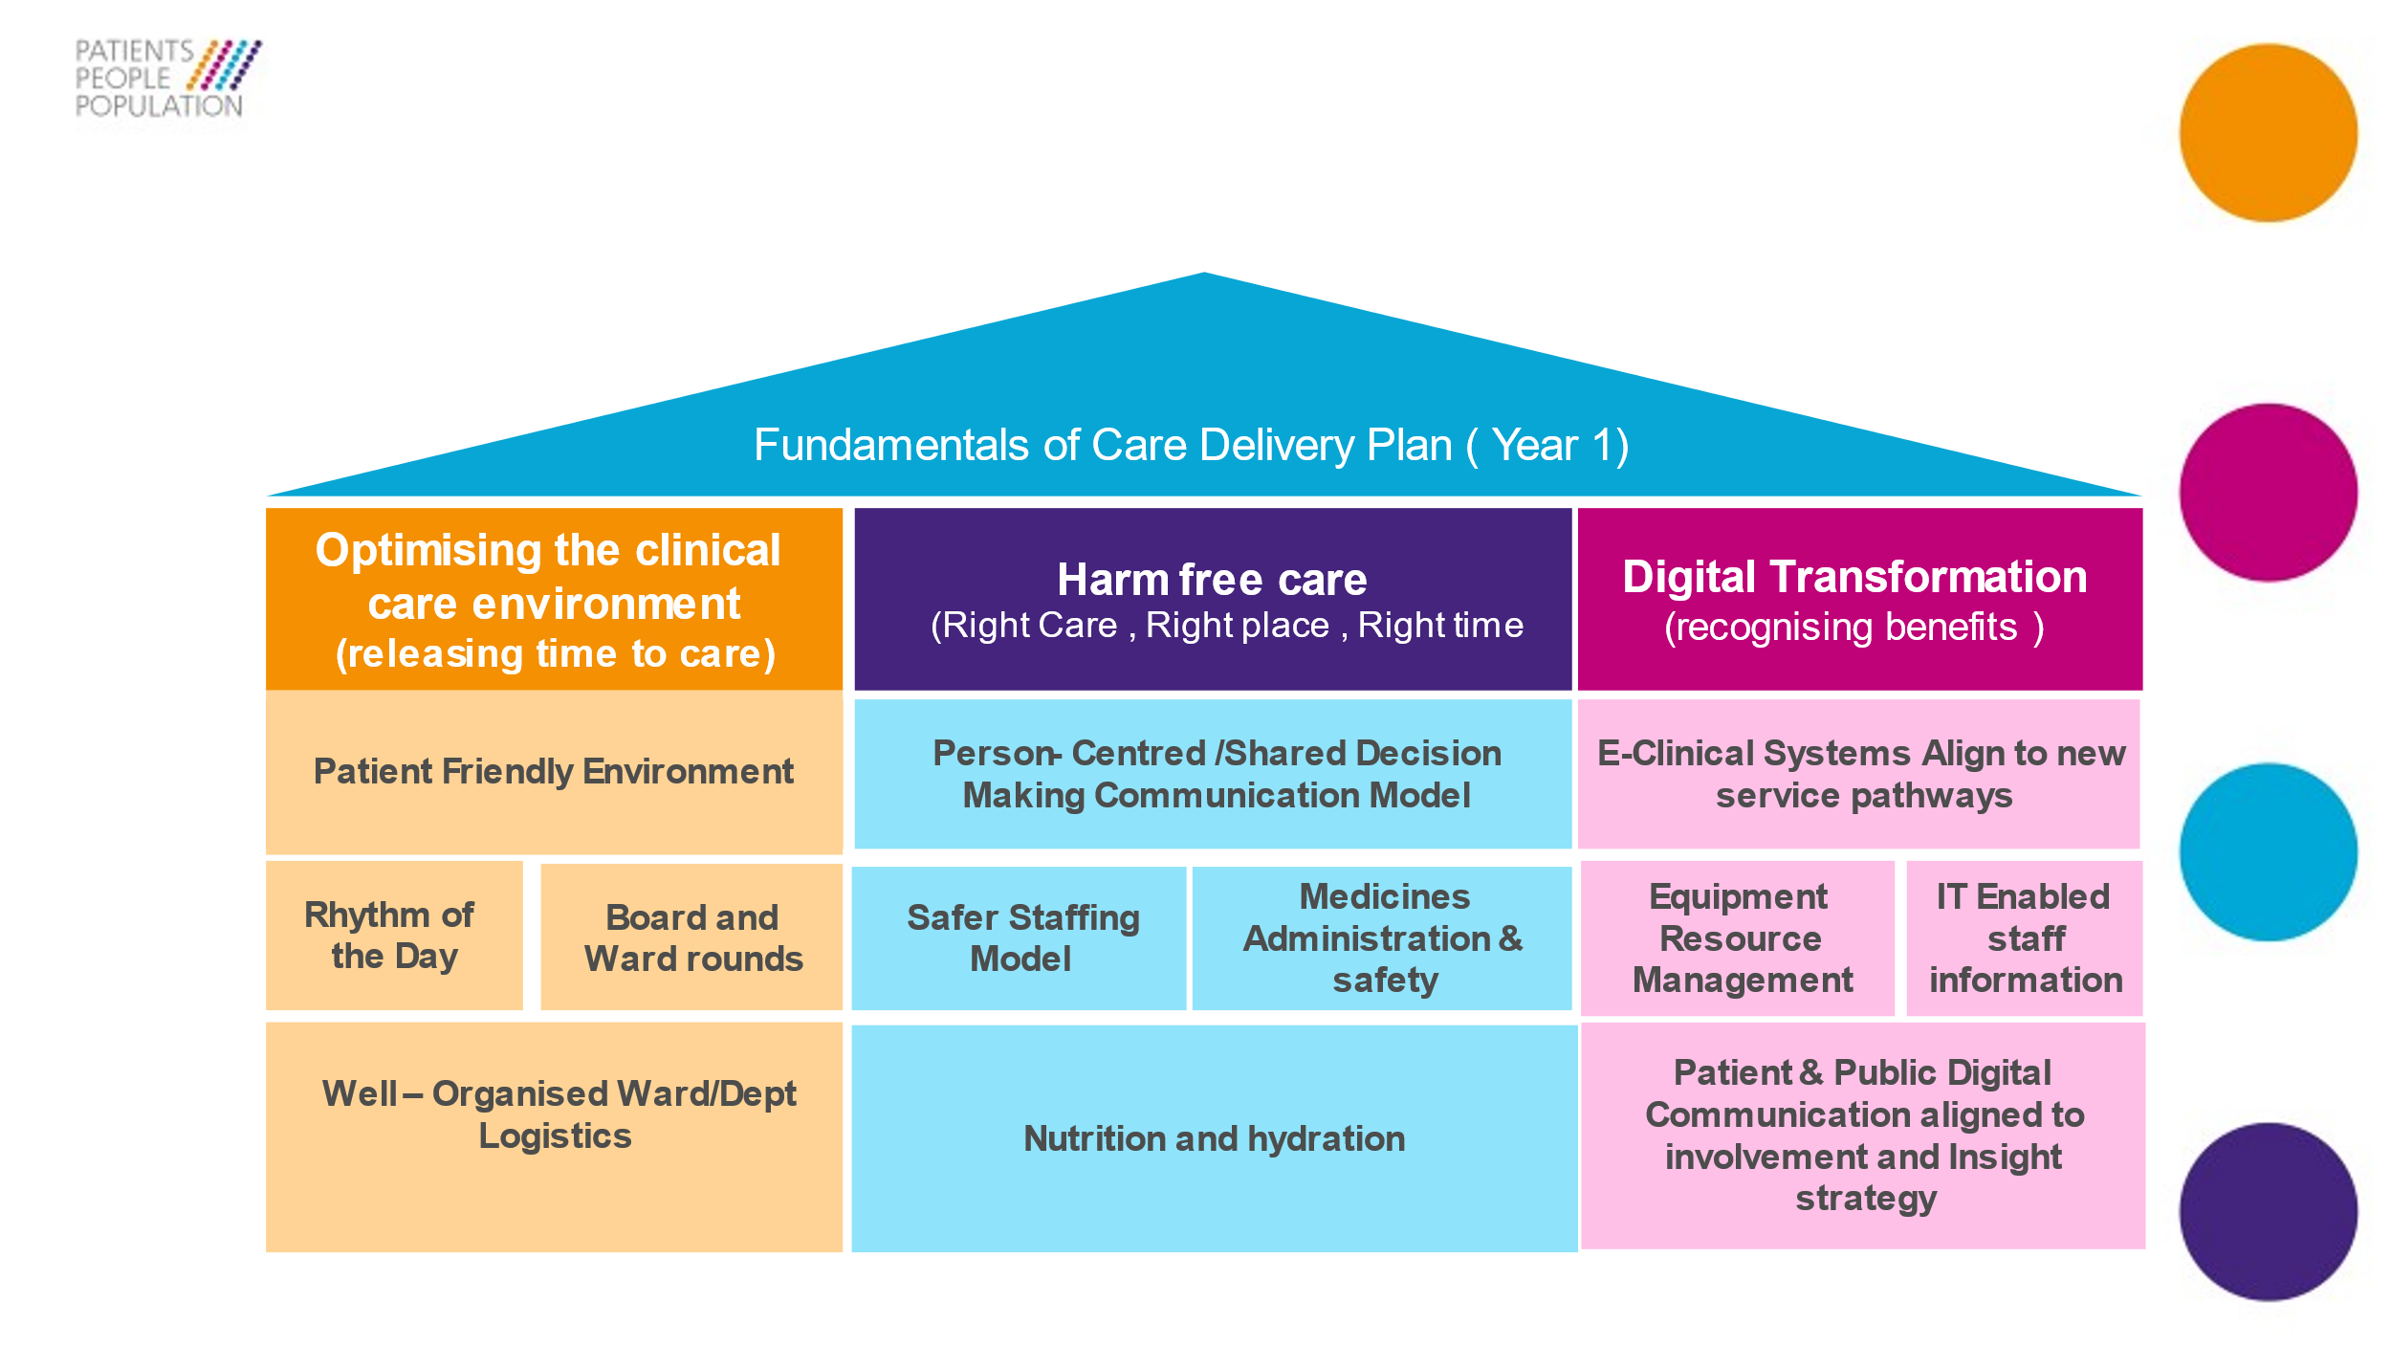

**MMUH Programme Company**

**Roles Specification: MMUH Clinical Change Manager**

**Band 8a**

1. **Role Objective:**

The MMUH Clinical Change Managers will work collaboratively with ward and department leaders to ensure that the MMUH Fundamentals of Care standard work projects are implemented, embedded, and sustained.

**2.0 Role Aims:**

* To act as a clinical leader across clinical groups to support delivery of the 12 FoC projects.
* To support the spread and adoption of standardisation principles across the organisation.
* To work collaboratively with MMUH Business Change Manager and MMUH Transformational Change Project Managers to support service operational readiness.
* To act as a Clinical Group communication champion for the MMUH programme
* To work collaboratively with clinical groups to give assurance regarding compliance of the FoC delivery success measures.

**3.0 Managerially and professionally accountability to**:

Associate Director of Nursing for MMUH Programme Company

**4.0 Key Relationships:**

* MMUH Programme Company
* MMUH Business Changes managers
* MMUH Transformational Change Project Managers
* Fundamentals of Care Leads (Core business)
* Group leadership teams: GDs, GDoP, GDoN
* Directorate leadership teams: CDs, Directorate General Managers, Matrons
* Local Leadership teams: Clinical lead, Operational Managers and Departmental/Ward Managers.
* Clinical Support teams (inc. Logistics, soft facilities management teams, pharmacy, imaging)

**5.0 Key Stakeholders:**

* MMUH Communication team
* Patients and community groups
* Patient Experience Insight team
* Patient Safety Team
* Finance (Benefits Realisation)
* IT and Clinical Digital System teams

**6.0 Responsibilities:**

|  |  |
| --- | --- |
| **Responsibility /Deliverable** | **Role Descriptors** |
| **To provide clinical leadership to the clinical group teams to support effective implementation of MMUH first year FoC projects and service operational readiness** | * Working collaboratively with clinical group leadership teams and local departmental/ward managers to support the implementation of the 12 projects. * Will identify and support wards and departments to test standardisation products. * To work collaboratively with group & directorate teams to ensure local key deliverables and project milestones are met. * To provide enhanced support where required. * Attend MMUH Clinical Group meetings and forums to give regular assurance and updates regarding the schemes of work, implementation of the programme |
| **To provide clinical expertise and support to teams in the delivery of standardisation work** | * To represent the clinical group at MMUH FoC standardisation project meetings. * To share learning – success metrics. |
| **Work with ward and departmental leaders to monitor sustainability of the project success metrics.** | * Lead on the implementation of PDSA (testing) cycles. * Monitor the progress of local implementation plans. * Establish biweekly MMUH progress huddles with local services and teams to monitor progress and support the mitigation of any constraints. * Provide group progress reports. * Participate in peer review activities. |
| **Develop CQI skills and expertise to support the implementation of standard work.** | * All CCMs will attend and participate in a LEAN and QI awareness programme. * Organise and co-ordinate local awareness events for clinical teams. * Support groups to identify local resources available to support with roll-out of induction and familiarisation. |
| **Act as a local agent to disseminate the staff MMUH communication and engagement strategy** | * Will ensure all wards and departments within the group have an updated MMUH Corner. * Will attend at MMUH huddles in local areas (at least one /week) * Will report back themes, areas of good practice. |

**7.0 Personal Specification:**

Applicants need to be a professional registrant, with relevant clinical experience at Band 7 or above.